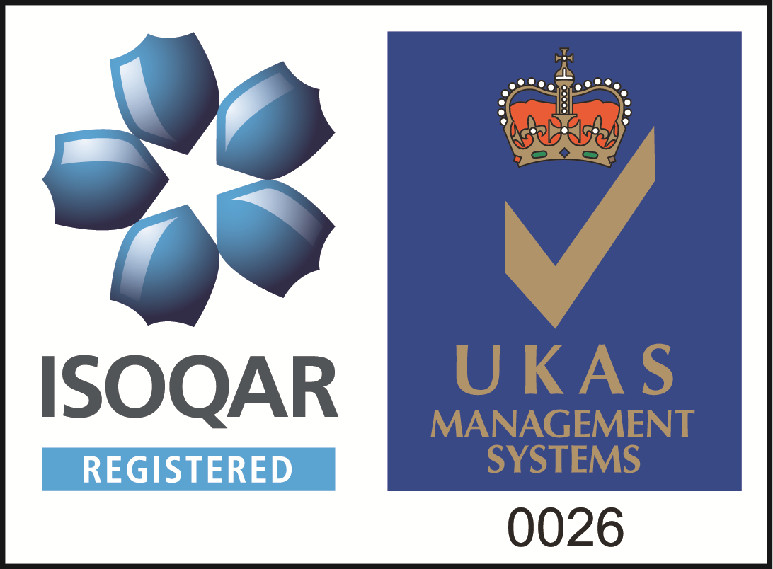
ESTABLISHED 1948

CLIFFORD HOUSE - HAMPTON HEATH - MALPAS - CHESHIRE - SY14 8LU

 01948820200  01948820232

 www.barlowsuk.co.uk

WEBSITE CASE STUDY SAMPLE

SITE/PROJECT ADDRESS – Offices, Crewe Business Park, Cheshire

PROJECT – Office Refurbishment - Electrical & Data installation

BRIEF DESCRIPTION/PROJECT OVERVIEW
Barlows were given the task of carrying out a second floor office refurb for a large worldwide company base on the Crewe Business Park who had taken over an additional floor to meet their ever expanding needs and growth. Barlows carried out the installation and adaption of 40no. 3 compartment floor boxes to suit the office layout, the complete installation of 160 new CAT6 Data points, The supply and installation of smart TV’s, HDMI Cabling and a back up UPS System.

WORKS CARRIED OUT

- Full Design and Electrical installation
- Full Design and installation of CAT6 Data installation
- Supply and installation of Smart TV’s including HDMI Cabling in boardrooms
- Back up UPS Installation
- Air Con supplies and lighting to new comms room area.
- NICEIC & Data Testing and Commisioning

PROJECT DURATION – eg – 5/6 weeks

PROJECT/CONTRACTS MANAGER - Richard Hamer

CLIENT TESTOMONIAL/ MANAGERS OVER VIEW
The whole installation was carried out to a very high standard, completed on time and enabled the company to carry out their office move on the day requested.
The client was very happy and we have since commenced on further projects with the same principal contractor.

Please attach all pictures relating to project!



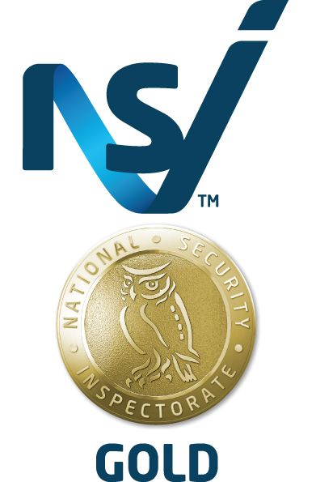
Directors : J E Barlow, D M Barlow, D Prince, A Caputo
Registered in England No. 2857344; VAT No. 625 1710 66
Directors : J E Barlow, D M Barlow, D Prince, A Caputo
Registered in England No. 2857344; VAT No. 625 1710 66
Directors : J E Barlow, D M Barlow, D Prince, A Caputo
Registered in England No. 2857344; VAT No. 625 1710 66

Accreditations

• NICEIC Approved Contractor - Electrical Installations in domestic, commercial, and Industrial (Enrolment No. 013052)
• NICEIC Domestic Installer - Domestic Electrical Installations (Registration No. 013052000)
• Gas Safe - Plumbing & Heating (Registration No. 203366)
• Constructionline - Building maintenance & construction (Registration No. 49281)
• NSI NACOSS - Electronic Security Systems
• BAFE – British Approvals of Fire Equipment (Registration No. 100923)
• ISO 9001 - Quality Assured (Membership No. 6396)
• ROSPA - The Royal Society for the prevention of accidents (Membership no.M406501630)
• OFTEC - The Oil Firing Technical Association (Registration No. C9521)

